Toronto Open Data Treasure Hunt

NOTE: This activity works as a standalone. However, if students are interested in better understanding what is Open Data, we recommend using this activity together with the City of Toronto Open Data 101 presentation. A sample activity sequence is shared below.
 | Activity | Resources | Time (minutes)
1 | Instructor delivers interactive presentation about City of Toronto open data. | City of Toronto Open Data 101 presentation | 20 minutes
2 | Students work alone or in group to complete the treasure hunt puzzle, using spreadsheets from the open data website. | Toronto Open Data Treasure Hunt | 30 minutes

This puzzle is also available on the City of Toronto Open Data website in the blog section at the following link: open.toronto.ca/open-data-day-treasure-hunt/
Materials needed:
- Computers with internet connection
- Computers with Excel or another software capable of manipulating .csv files
- Worksheet (on the next page)

Toronto Open Data Treasure Hunt
Use the City of Toronto’s Open Data website to fill out this puzzle: https://open.toronto.ca
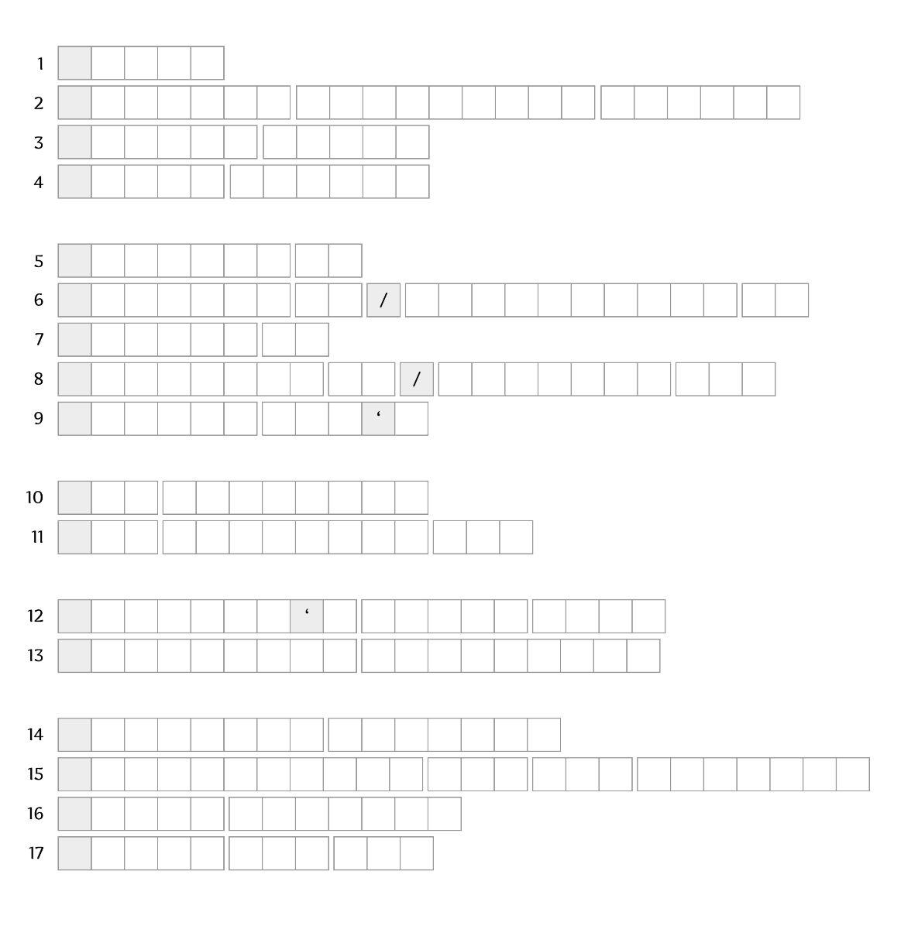
- What was the #8 most common dog name for all licensed dogs in 2022?
- Which Parks & Recreation facility has both wi-fi and ping pong tables?
- What City-owned child care center is located at 3495 Lake Shore Blvd W?
- Which City of Toronto dog off leash park has a wading pool for dogs (aka a dog fountain!)?
- On which street is the City’s only recorded Acer tataricum ‘Garann’ street tree located?
- Which intersection had the 2nd most red light camera charges in 2025?
- On what street is the condo with this Short Term Rental operator registration number: STR-2412-HMWSBX?
- At what intersection was a truck fire incident called in to Toronto Fire on January 6th 2011?
- Which business has the business license number: B71-5228678?
- On which Ward 2 street is there a building with 17 storeys, and 73 units?
- On which street is the sewer gravity main with the largest diameter?
- What is the Eastern-most beach sampled daily for water quality by City of Toronto during summer?
- What is the name of the ward designated as Ward 3?
- What is the largest theatre available for rent via Toronto Public Library, by capacity?
- What was the #1 service request type made of 311, in 2025?
- What is the largest BIA in Toronto?
- What is the title of the granite public art piece created by Peter Roller, located at Scarborough Civic Centre?

FINAL ANSWERS
 | Answer | Clue | Dataset
D | Daisy | - What was the #8 most common dog name for all licensed dogs in 2022? | /licensed-dog-and-cat-names/
A | Antibes Community Centre | - Which Parks & Recreation facility has both wi-fi and ping pong tables? | /parks-and-recreation-facilities/
T | Thomas Berry | - What City-owned child care center is located at 3495 Lake Shore Blvd W?
A | Allan Garden | - Which City of Toronto dog off leash park has a wading pool for dogs (aka a dog fountain!)? | /off-leash-areas/
W | Wimpole Dr | - On which street is the City’s only recorded Acer tataricum ‘Garann’ street tree located? | /street-tree-data/
A | Adelaide St. and Parliament St. | - Which intersection had the 2nd most red light camera charges in 2025? | /red-light-camera-annual-charges/
N | Nelson St | - On what street is the condo with this Short Term Rental operator registration number: STR-2412-HMWSBX? | /short-term-rentals-registration/
T | Tapscott Rd / Steeles Ave E | - At what intersection was a truck fire incident called in to Toronto Fire on January 6th 2011 | /fire-incidents/
S | Sneaky Dee’s | - Which business has the business license number: B71-5228678? | MLS licensing
T | The Kingsway | - On which Ward 2 street is there a building with 17 storeys, and 73 units? | /apartment-building-evaluation/
O | Old Sheppard Ave | - On which street is the sewer gravity main with the largest diameter? | /sewer-gravity-mains/
B | Bluffer's Beach Park | - What is the Eastern-most beach sampled daily for water quality by City of Toronto during summer? | /toronto-beaches-water-quality/
E | Etobicoke Lakeshore | - What is the name of the ward designated as Ward 3?
F | Fairview Theatre | - What is the largest theatre available for rent via Toronto Public Library, by capacity? | /library-branch-space-rentals/
R | Residential bin lid damaged | - What was the #1 service request type made of 311, in 2025? | /311-service-requests-customer-initiated/
E | Emery Village | - What is the largest BIA in Toronto? | /business-improvement-areas/
E | Earth and Sky | - What is the title of the granite public art piece created by Peter Roller, located at Scarborough Civic Centre?

