Explore Your Neighbourhood Using Data

NOTE: We recommend using this activity together with the City of Toronto Open Data 101 presentation. A sample activity sequence is shared below.
 | Activity | Resources | Time (minutes)
1 | Instructor delivers interactive presentation about City of Toronto open data. | City of Toronto Open Data 101 presentation | 20 minutes
2 | Students work alone or in groups to use the Toronto Open Data website to complete the worksheet | Explore Your Neighbourhood Using Data worksheet | 20 minutes

Materials needed:
- Presentation: City of Toronto Open Data 101 (recommended)
- Computers with internet connection
- Worksheet (on the next page)

Explore Your Neighbourhood Using Data

Use publicly available open data to complete the worksheet below about your neighbourhood. The City of Toronto’s open data website can be found at: open.toronto.ca

STEP 1: Identify what streets bound your neighbourhood.
- Visit https://open.toronto.ca/dataset/neighbourhoods/
- Use the “Preview” of the “Neighbourhoods” map to find the name and the boundary of your school’s neighbourhood.
- Note the name of the neighbourhood.
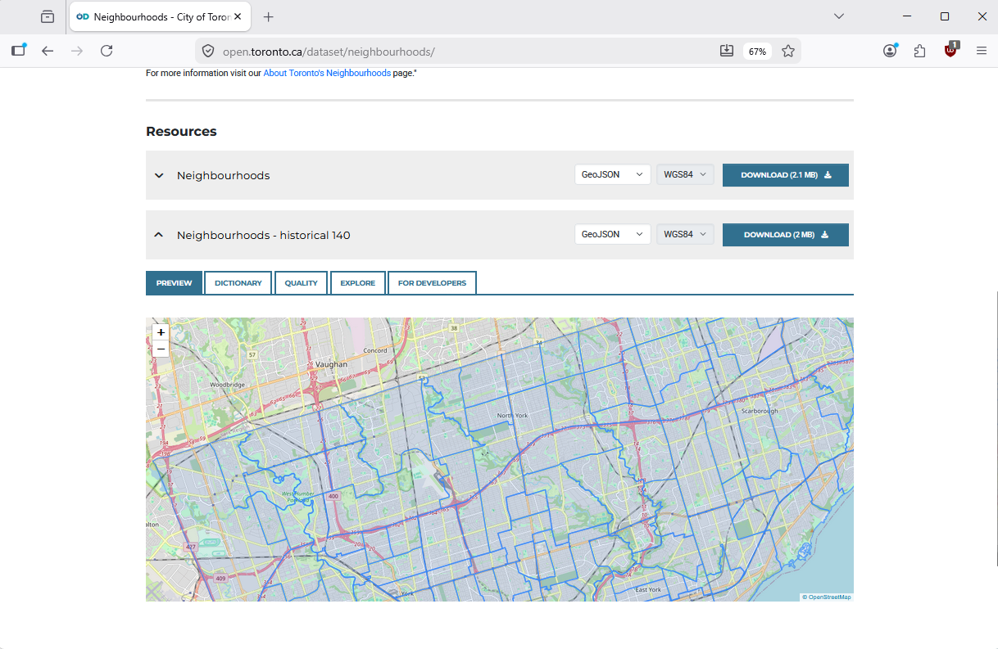
STEP 2: Search the Toronto Open Data catalogue to find information about the topics in the chart on the next page. Use “Preview” to count how many of each there are in your neighbourhood.
STEP 3: Fill in the “Neighbourhood factsheet” on the next page. You can add your own interest to the factsheet!
Neighbourhood factsheet for | Neighbourhood name
Located between: | Cross streets bounding neighbourhood

In this neighbourhood, there are…
Public amenity | Quantity in the neighbourhood
Schools
Parks and Recreation facilities
Pollinator gardens
Red Light Cameras

